40.40: a) 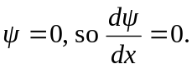 b)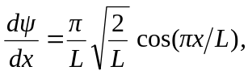 and as 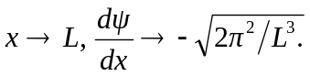 Clearly not. In Eq. (40.1), any point where 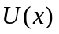is singular necessitates a discontinuity in 